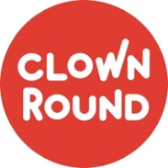
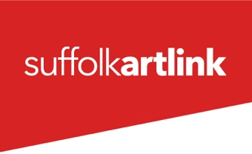
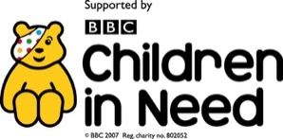

CLOWN ROUND CALL-OUT

Suffolk Artlink are looking to expand their Healthcare Clown team working on the Clown Round project currently in Hospitals and Children’s Hospices in Suffolk, Norfolk and Essex. We are particularly keen to hear from applicants based in or near Ipswich and Colchester and especially welcome applications from Global Majority artists and those currently underrepresented in the work. Suffolk Artlink is an equal opportunities and disability confident employer. We value diversity and welcome applications from all backgrounds.

- You will have experience of working with children and young people and a passion for therapeutic and person-centred play.
- You will be a creative individual/performer who is skilled/experienced in clowning and improvisation and is imaginative and funny!
- You may additionally have music and movement skills, basic circus abilities or other artistry such as puppetry or storytelling.
- Have sensitivity, empathy and awareness.
- Be able to respond positively, authentically and intuitively to vulnerable people and stressful situations.
- Be a good listener and able to work effectively in pairs, as part of a team and within an organisation.
- You will have good self-awareness, emotional intelligence and mental health practices to support your resilience for the work.
- Be organised, reliable, punctual, well presented, and have good availability for part-time, freelance work.
- You will be able to attend Hospital and Hospice visits independently.

Please send CV, photo and a website/video link as an example of your work if you have one to lucy@suffolkartlink.org.uk by the application deadline of 12pm Monday 5th September 2022 with the email title: CLOWN ROUND CALL-OUT
In your email please give a brief introduction of yourself and your work, stating where you are based and a short paragraph about why you are interested in becoming a healthcare clown. If preferred this can be submitted as a video. We will respond to all applicants within 2 days of the deadline.

If invited for the audition workshop day you will be expected to be available to come to Ipswich on Sunday 11th September and after this selection phase you may be invited to come and observe some sessions in hospital on either 15th, 22nd, 27th or 29th September. You must be available for at least one of these dates.

Pending DBS checks, hospital training/paperwork and completing an online Safeguarding course you will be invited for training Oct-Dec and potentially entering work officially on completion of this programme from the start of 2023.

Fee information:

- The audition is travel expenses only.
- Training is paid at £50 per half day and £100 per full day.
- After the training period the fee is £120 per half day session, plus £25 to complete and submit an evaluation form and a contribution towards travel.
- Offers of ongoing work are funding dependent.

