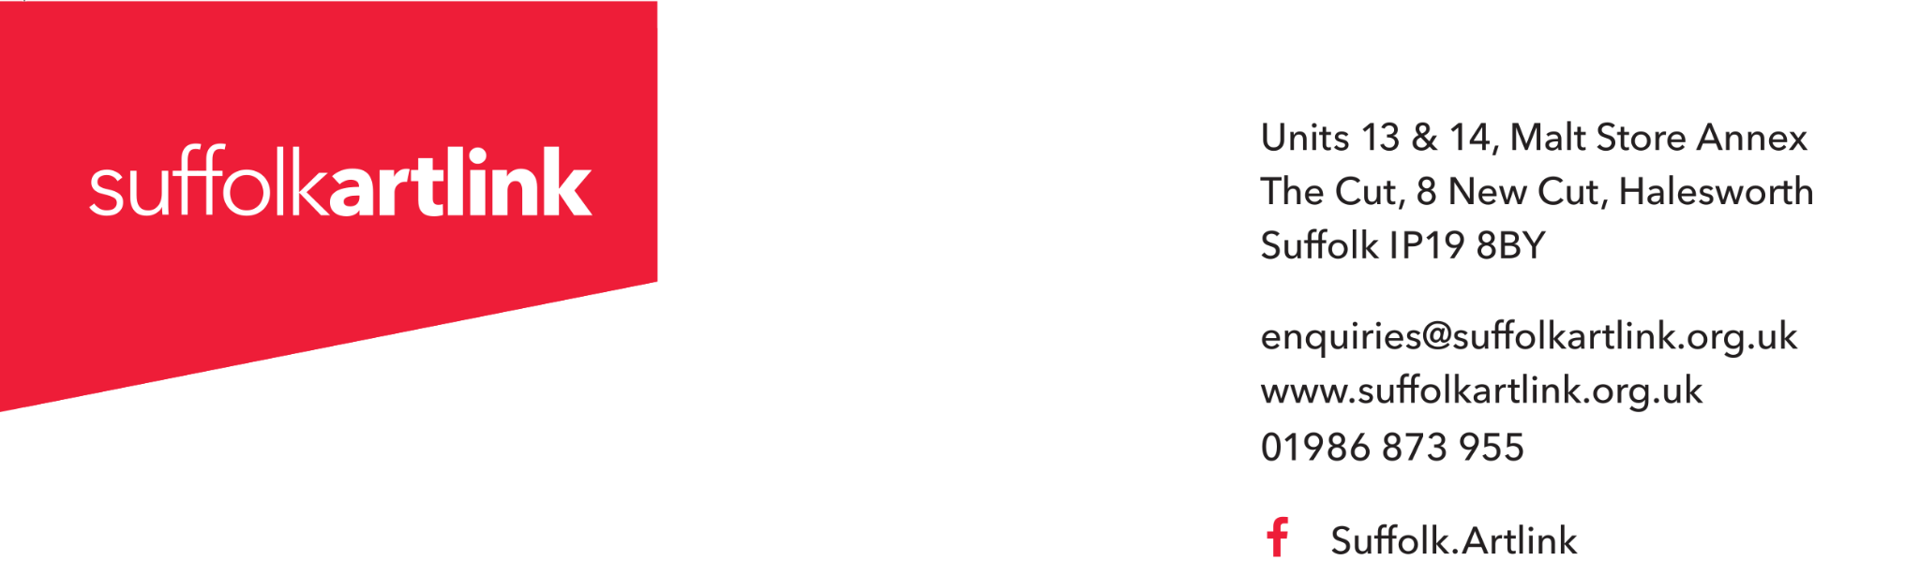
Job Description – Producer
Job Title: Producer
Reports to: Director
Hours: 3 days per week (22.5 hours)
Location: Suffolk Artlink office in Halesworth with travel to activities across Suffolk (opportunities to work from home as agreed)
Salary: £16,068 per annum (£26,780 FTE)
Contract: Permanent
Purpose of the Role
The Producer plays a key role in supporting the successful delivery of Suffolk Artlink's creative programmes across the county. Working closely with the Senior Producers, artists and partners, the Producer will coordinate projects from planning through to delivery, ensuring activities run smoothly and participants have a positive, inclusive experience.
The role involves coordinating communications with participants, artists, venues and partner organisations, maintaining accurate project records, assisting with session planning and logistics, and attending community-based creative sessions to provide practical support. The Producer helps ensure participants receive an excellent experience while enabling artists and Senior Producers to focus on programme development.
Key Responsibilities
Project Coordination and Delivery
- Support the planning, coordination and successful delivery of Suffolk Artlink's participatory arts programmes across Suffolk.
- Work closely with the Senior Producer(s) to coordinate project schedules, venues, artists, resources and session logistics.
- Prepare project documentation, including registers, consent forms, risk assessments and other administrative paperwork.
- Coordinate bookings with community venues, partner organisations and freelance artists.
- Monitor project supplies and arrange the ordering, preparation and distribution of materials and equipment.
- Maintain accurate participant databases, project records and filing systems in accordance with GDPR requirements.
- Support the effective administration of projects from planning through to completion.
Participant, Artist and Partner Communication
- Act as a welcoming, professional first point of contact for participants, artists and community partners.
- Communicate with participants regarding session dates, venues, transport arrangements and other project information.
- Liaise with freelance artists to coordinate session schedules, practical arrangements and resource requirements.
- Build positive relationships with participants, artists and partner organisations, helping to create a collaborative and supportive culture.
- Respond to routine enquiries by telephone, email and in person in a timely and professional manner.
- Support participant recruitment and engagement activities where appropriate.
- Represent the organisation at external events as required
Session Delivery
- Attend artist-led workshops, events and community sessions across Suffolk to support delivery.
- Welcome participants and help create inclusive, safe and supportive environments where everyone feels able to take part.
- Assist with preparing venues, setting up equipment and materials, and clearing away after sessions.
- Support artists with practical tasks during workshops and respond to participant needs where appropriate.
- Help ensure activities are delivered safely and in line with safeguarding, health and safety and organisational procedures.
Monitoring, Evaluation and Reporting
- Collect attendance data, participant feedback and other monitoring information across projects.
- Support the use of evaluation tools and assist in gathering qualitative and quantitative evidence of project outcomes.
- Record participant stories, case studies and photographs (with appropriate permissions) to help demonstrate impact.
- Gather information and contribute to reports for funders, partners and internal learning.
Financial and Administrative Support
- Assist with monitoring project expenditure against agreed budgets.
- Process purchase orders, invoices and expense claims in accordance with organisational procedures.
- Maintain organised electronic and paper filing systems to support effective programme management.
Quality, Safeguarding and Compliance
- Follow Suffolk Artlink's safeguarding, health and safety, equality, diversity and inclusion, environmental and data protection policies at all times.
- Maintain confidentiality regarding participants, staff, partners and organisational information.
- Report safeguarding, health and safety or other concerns promptly using organisational procedures.
- Promote inclusive practice and ensure activities are accessible and welcoming to all participants.
Team Working and Professional Practice
- Work collaboratively across Suffolk Artlink to support the successful delivery of programmes and organisational priorities.
- Represent Suffolk Artlink professionally with participants, artists, partners and members of the public.
- Participate in supervision, team meetings, reflective practice and professional development opportunities.
- Undertake any other duties commensurate with the responsibilities and grade of the post.

Person Specification
Criteria | Essential | Desirable
Experience & Knowledge | Some experience of organising, supporting or contributing to projects, activities, events or programmes. | Experience in arts, cultural, voluntary, community, education or health settings.
 | Experience communicating with and supporting a range of people. | Experience working with people who experience barriers to participation.
 | Understanding of inclusive and respectful ways of working with people. | Understanding of participatory arts or creative health.
Skills & Abilities | Good organisation, time management and attention to detail. | Experience using CRM or project management systems.
 | Clear written and verbal communication skills. | Ability to create basic promotional or social media content.
 | Ability to build positive relationships and work well with others.
 | Confident using standard digital tools such as Microsoft Office or Google Workspace.
Personal Qualities | Friendly, approachable, reliable and proactive.
 | Curious, willing to learn and able to respond flexibly to different situations.
 | Commitment to equality, diversity and inclusion.
 | Interest in the role creativity can play in improving people's lives and strengthening communities.
Other Requirements | Ability to travel independently throughout Suffolk and willingness to work occasional evenings and weekends.
 | Satisfactory Enhanced DBS check. (Suffolk Artlink arranges and pays for the check)

How to Apply
Closing date for applications: Monday 5th October 2026 at 10am
(We are shortlisting for interview on Wednesday 7th October 2026)
Interview date: Wednesday 14th October 2026
Application is by application form and cover letter.
Applications may be emailed to: jobs@suffolkartlink.org.uk
or posted to: Suffolk Artlink, Units 13 & 14, Malt Store Annex, The Cut, 8 New Cut, Halesworth, IP19 8BY
Please note that applications received late for any reason cannot be considered.

